Avah Denesse E. Ayop

BSIT-1R1

Implementation of Stacks

Source Code:

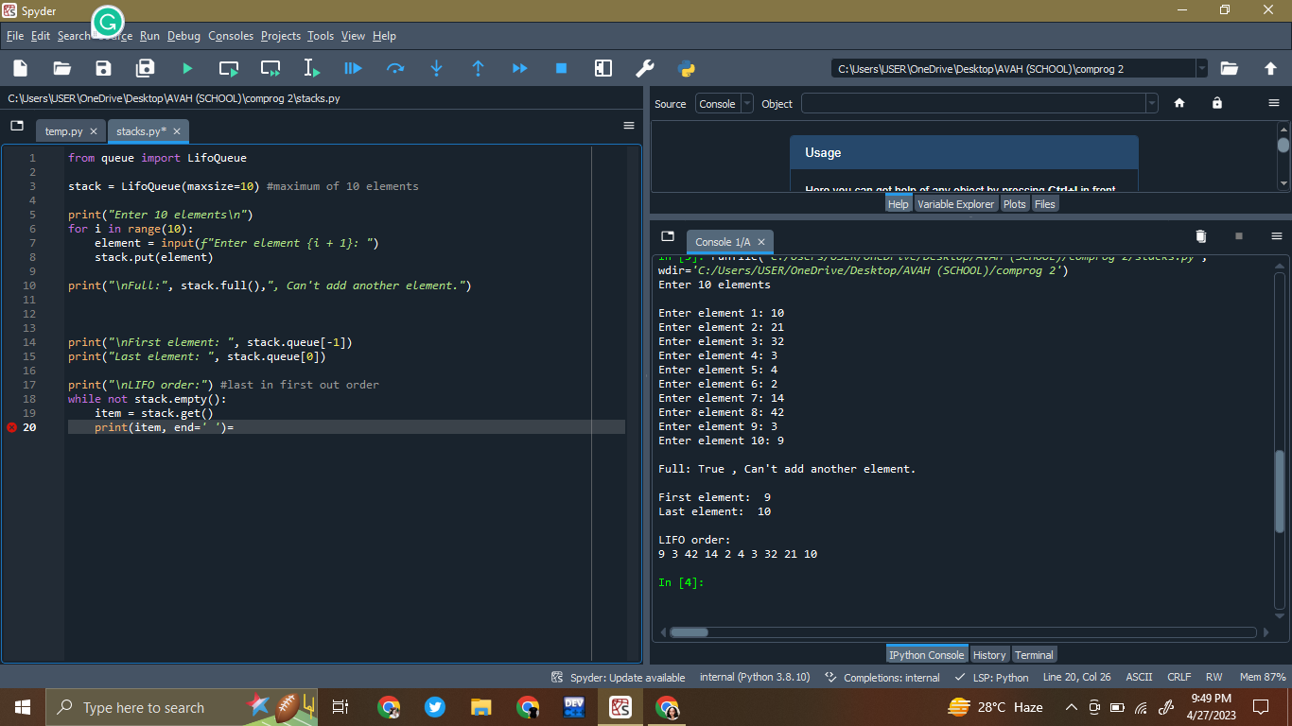

from queue import LifoQueue

stack = LifoQueue(maxsize=10) #maximum of 10 elements

print("Enter 10 elements\n")

for i in range(10):

element = input(f"Enter element {i + 1}: ")

stack.put(element)

print("\nFull:", stack.full(),", Can't add another element.")

print("\nFirst element: ", stack.queue[-1])

print("Last element: ", stack.queue[0])

print("\nLIFO order:") #last in first out order

while not stack.empty():

item = stack.get()

print(item, end=' ')

Program Output:

